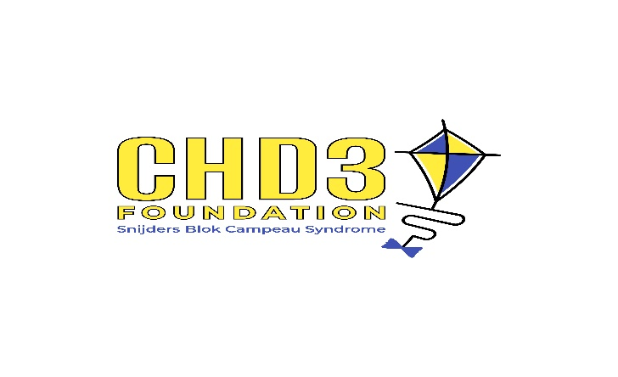
CHD3 Foundation Board Member Application
Thank you for your interest in serving on the Board of Directors for the CHD3 Foundation. Our mission is to [insert mission statement]. Board members play a vital role in advancing this mission through leadership, advocacy, and support.
Please complete the application below.
Contact Information
- Full Name: ___________________________________
- Address: _____________________________________
- City/State/ZIP: _______________________________
- Phone: _______________________________________
- Email: ________________________________________

Background & Experience
- Current Occupation / Title: _________________________________
- Employer / Organization: ___________________________________
- Education (degrees, certifications, or relevant training):

- Skills / Expertise (check all that apply):
☐ Nonprofit Governance
☐ Finance / Accounting
☐ Fundraising / Development
☐ Marketing / Communications
☐ Legal
☐ Strategic Planning
☐ Healthcare / Research
☐ Advocacy / Public Policy
☐ Other: ______________________________________

Board Service & Volunteer Experience
- Have you served on a nonprofit board before? ☐ Yes ☐ No
If yes, please list organizations and roles:

- Please describe any volunteer work or community involvement relevant to our mission:

Commitment
Board members are expected to:
- Attend quarterly board meetings (in person or virtual).
- Participate actively in at least one committee.
- Advocate for the mission of the CHD3 Foundation.
- Contribute time, talents, and financial support.
- Are you able to commit to these responsibilities? ☐ Yes ☐ No
- Are you willing to contribute a personal annual gift and assist with fundraising efforts? ☐ Yes ☐ No

Why the CHD3 Foundation?
- Why are you interested in serving on the Board of the CHD3 Foundation?

- What unique perspective, skills, or connections would you bring to our Board?

- Do you have a friend or family member who has CHD3 / Snijders Blok-Campeau Syndrome?

References
Please provide the names, email and phone number for two references:

Signature
I certify that the information provided in this application is true and complete to the best of my knowledge.
Signature: _____________________________________ Date: ___________

Send completed application to chd3foundation@gmail.com for consideration.

